Supplementation

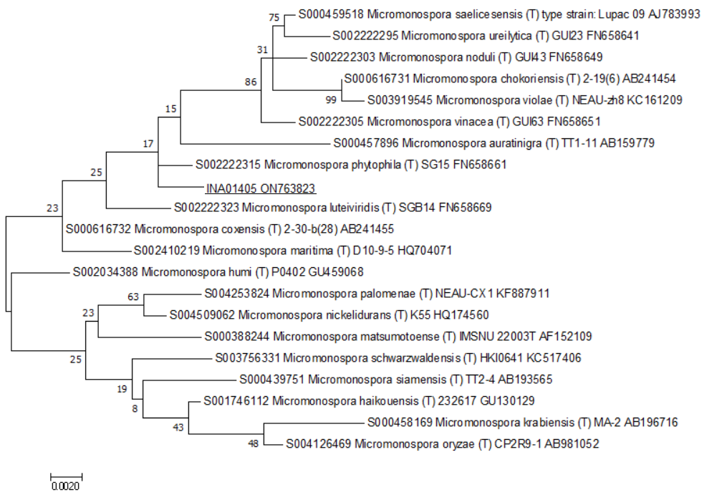
Figure S1. Phylogenetic position of the strain Micromonospora phytophila-like INA 01405 based on the results of comparative analysis of the 16S rRNA gene nucleotide sequences of typical strains. The scale corresponds to two base substitutions for every 1000 nucleotides (evolutionary distance).

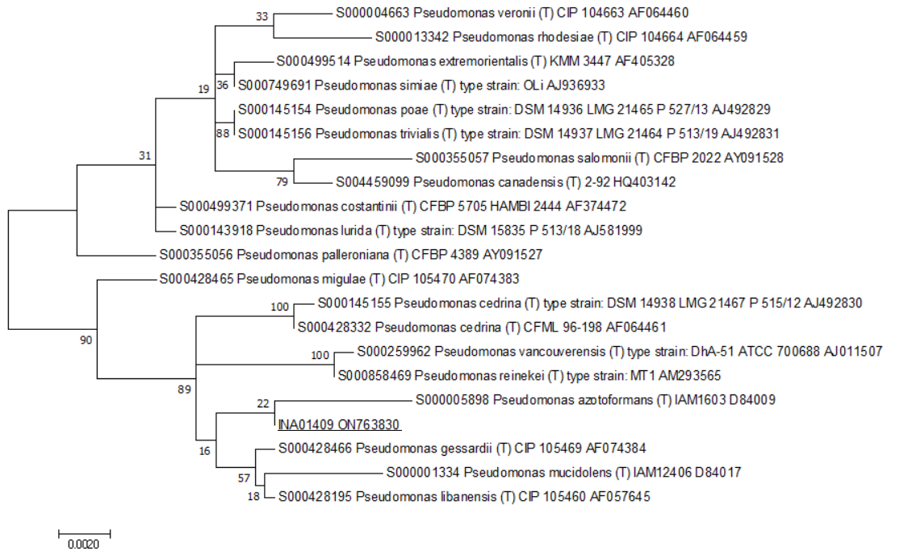
Figure S2. Phylogenetic position of the strain Pseudomonas gessardii-like INA 01409 based on the results of comparative analysis of the 16S rRNA gene nucleotide sequences of typical strains. The scale corresponds to two base substitutions for every 1000 nucleotides (evolutionary distance).

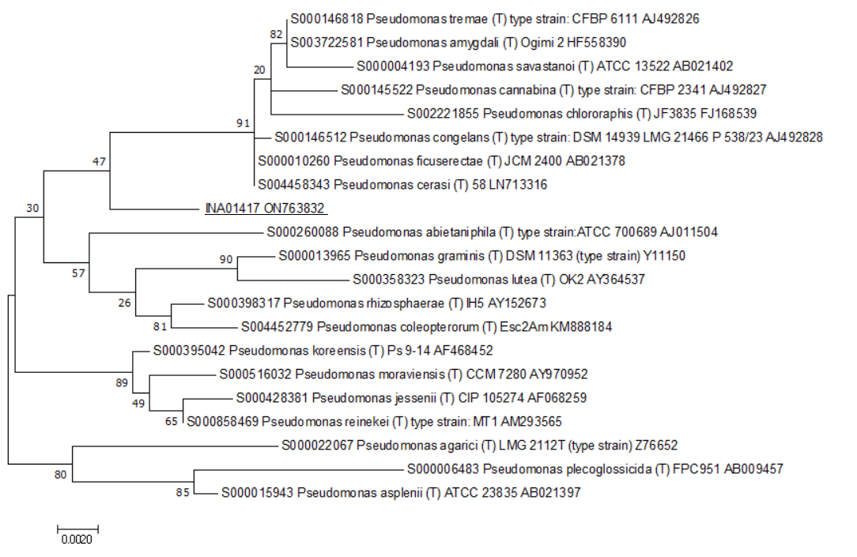
Figure S3. Phylogenetic position of the strain Pseudomonas rhizosphaerae-like INA 01417 based on the results of comparative analysis of the 16S rRNA gene nucleotide sequences of typical strains. The scale corresponds to two base substitutions for every 1000 nucleotides (evolutionary distance).

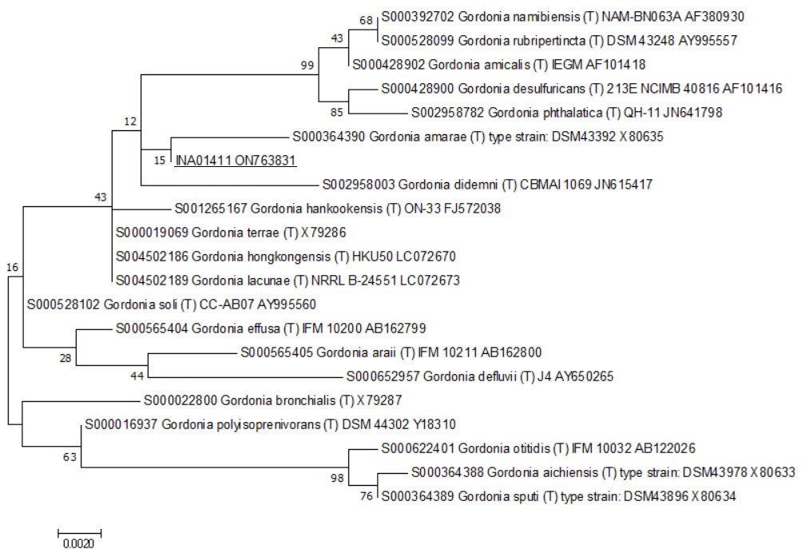
Figure S4. Phylogenetic position of the strain Gordonia sp. INA 01411 based on the results of comparative analysis of the 16S rRNA gene nucleotide sequences of typical strains. The scale corresponds to two base substitutions for every 1000 nucleotides (evolutionary distance).
Table S1. Antibiotics previously described in representatives of the studied species
Producer of Antibiotics | Antibiotics | Type of Activity | References
Bacillus thuringiensis | Endotoxins Cry and Cyt | Lethal to insect larvae and are broadly cytolytic to vertebrate as well as invertebrate cells; activity against Micrococcus luteus, and clinical isolate Escherichia coli and Staphylococcus aureus | [18,23,33–35]
Bacillus thuringiensis | Zwittermicin A  linear aminopolyol | High activity against the Oomycetes and a moderate activity against some Gram-negative bacteria (Pantoea agglomerans LS005) and many plants pathogenic fungi (Alternaria, Fusarium, Helminthosporium, and Ustilago) | [36,37]
Bacillus thuringiensis | Lipopeptide biosurfactant | F. oxysporum | [38]
Bacillus thuringiensis | Bacteriocins: Bacthuricin F103, Entomocin 110, Bacthuricin F4, Thuricin 439, Thuricin 7, Tochicin, Thuricin, Thuricin 4AJ1, Thuricin Z, BtCspB | Diverse Bacillus species and other Gram-positive bacteria | [39–42]
Bacillus thuringiensis | Bacteriocins: Thuricin H | Gram-positive (includes St. aureus and Micrococcus luteus) | [39]
Bacillus thuringiensis | Bacteriocins: Thuricin CD | Clostridioides spp. (includes Clostridioides difficile) exclusively | [39]
Bacillus thuringiensis | Bacteriocins: Thuricin Bn1, Thuricin S, Thuricin 17 | Gram-positive and Gram-negative bacteria | [39]
Bacillus thuringiensis | Bacteriocins: Morricin 269, Kurstacin 287, Kenyacin 404, Entomocin 420, Tolworthcin 524, Entomocin 9 | Gram-positive and Gram-negative bacteria, fungi | [39]
Gordonia sp. | Cyclo([iso]leucylprolyl), cyclo(phenylalanylprolyl), C₅₂H₇₄N₁₀O₁₁, C₃₅H₂₈N₆O₈, C₂₈H₄₁N₅O₁₀, the peptide Gly-Pro-Phe-Pro-Ile, nocardichelin A, nocardichelin B and C₄₂H₆₉N₅O₈ | Bacillus subtilis (ATCC6633) and St. aureus (MRSA); A. fumigatus ATCC46645; anti-parasitic (Trypanosoma cruzi), and anti-cancer activity against several cell lines (melanoma A2058, liver HepG2, colon HT29, breast MCF7 and pancreatic MiaPaca) | [43,44]
Gordonia sp. | Circumcin A-C, Kurasoin B, Soraphinol C, Bendigole A-C, Canthxanthin | Anticoccidial agents, inhibiting Herpes simplex virus, modestly inhibiting human protein farnseyltransferase (FTase) | [45–46]
Table S1. Cont.
Producer of Antibiotics | Antibiotics | Type of Activity | References
Gordonia sp. | – | St. aureus (MRSA), B. cereus, E. coli, and Candida albicans | [47]
Gordonia sp. | 3-formyl-2,4-dihydroxy-6-methylbenzoic acid 3-hydroxy-4- methoxycarbonyl -2,5-dimethylphenyl ester | Antifungal activity against plant pathogenic fungi Curvularia sp., Colletotrichum gloeosporioides, Rhizoctonia solani, Corynespora cassiicola, and Fusarium sp. | [48]
Gordonia sp. | Mojavensin A | C. albicans, Trichophyton rubrum, Aspergillus fumigatus and A. niger | [49]
Gordonia sp. | Cyclic (leucine-leucine) dipeptide | E. coli | [49]
Gordonia sp. | Actinomycin D and Actinomycin X2 | St. aureus ATCC 43300 (MRSA) | [49]
Gordonia sp. | – | St. aureus INA 00761 (MRSA), St. aureus FDA 209P (MSSA), and Micrococcus luteus NCTC 8340 | [50]
Neobacillus drentensis | Cyclic peptides | C. albicans | [51]
Neobacillus drentensis | – | Antifungal activity (Botrytis cinerea, F. solani, F. oxysporum, Rhizoctonia solani) | [52]
Nocardia salmonicida subsp. cummidelens | C₂₁H₂₈N₇O₁₄ | Gram-negative (E. coli ATCC 25922, Pseudomonas aeruginosa ATCC 27853, Klebsiella pneumoniae ATCC 700603), fungi A. niger ATCC 1015 and A. fumigatus ATCC 1022 | [53]
Pantoea agglomerans | Phenazine antibiotic D-alanylgriseoluteic acid (AGA) | Gram-positive and Gram-negative bacteria (including the fireblight pathogen Erwinia amylovora) | [54]

Table S1. Cont.
Producer of Antibiotics | Antibiotics | Type of Activity | References
Pantoea agglomerans | Phenazine antibiotics | Clavibacter michiganensis, Burkholderia andropogonis, Chryseobacterium balustinum, Dickeya zeae, Pectobacterium carotovorum, and P. putida, and against foodborne pathogens such as Salmonella enterica and E. coli O157:H7 | [55]
Pantoea agglomerans | Pantocin, herbicolin I, dapdiamide family of antibiotics, microcins | Er. amylovora (fire blight) | [56–59]
Pantoea agglomerans | PNP-2 (Pantoea Natural Product 2) | Gram-positive Staphylococcus sp., Streptococcus sp., and Gram-negative Aeromonas sp., Enterobacter sp., E. coli, Klebsiella sp., Kosakonia sp., Pseudocitrobacter sp., and Salmonella sp. | [60]
Pseudomonas gessardii | Rhamnolipids (surface-active molecules) | Listeria monocytogenes and Stenotrophomonas maltophilia | [61]
P. poae | – | Phytopathogenic fungi (F. graminearum, F. sporotrichioides, F. сulmorum, Alternaria alternata), Gram-positive and Gram-negative bacteria (Clavibacter michiganensis subsp. sepedonicum, Erwinia carotovora (syn. Pectobacterium carotovorum subsp. atroceptica) | [62–64]
P. poae | – | Penicillium expansum | [65]
P. poae | Lipopeptide Poaeamide (orfamide family) | Oomycetes, including Phytophthora capsici, Phytophthora infphestans, and Pythium ultimum | [66]
P. rhizosphaerae | Diketopiperazine and benzene-type secondary metabolites | Gram-negative (Loktanella hongkongensis, Ruegeria sp., Pseudoalteromona sp.) and Gram-positive bacteria (M. luteus, B. cereus), and against insect larvae (against barnacle larvae Balanus amphitrite and bryozoans Bugula neritina) | [67]
Table S1. Cont.
Producer of Antibiotics | Antibiotics | Type of Activity | References
Staphylococcus argenteus | – | – | –
Streptomyces badius | Feigrisolide B, feigrisolide C and dinactin | Antifungal activity (against Colletotrichum gloeosporioides) | [68]
Streptomyces badius | Marilone C | Antioxidant activity, anticancer activity, and antiviral activities | [69]
S. camponoticapitis | – | – | –
S. chartreusis | Chartreusin | Gram-positive bacteria (including Mycobacterium tuberculosis), anti-cancer agents | [70]
S. chartreusis | Elsamicin A | Anti-cancer agents | [71]
S. chartreusis | Tunicamycins, N-deacyltunicamycin | Nucleoside antibiotic that inhibits N-linked glycosylation and blocks the formation of N-glycosidic protein-carbohydrate linkages | [72,73]
S. chartreusis | Calcimycin, cezomycin | Gram-positive bacteria and some fungi | [74,75]
S. clavifer | – | – | –
S. coelicoflavus | – | B. subtilis, St. aureus, St. epidermidis, Enterococcus faecium, Xanthomonas sp. pv. badrii, C. albicans | [76]
S. coelicoflavus | 5-amino-2-(6-(2-hydroxyethyl)-3-oxononyl) cyclohex-2-enone; 8-(aminomethyl)-7-hydroxy-1-(1-hydroxy-4-(hydroxylmethoxy)-2,3-dimethylbutyl)-2-methyl dodecahydro phenanthren-9(1H)-one; 1-((E)-2-ethylhex-1-en-1-yl)2-((E)-2-ethylidenehexyl)cyclohexane-1,2-dicarboxylate | St. aureus, B. cereus P. aeruginosa and P. vulgaris, and weak antifungal activity; exhibit in vitro antioxidant and anti-inflammatory activity | [77]
Table S1. Cont.
Producer of Antibiotics | Antibiotics | Type of Activity | References
S. microflavus | Analog of nemadectins | Acaricidal and nematocidal activities | [78]
S. microflavus | Fattiviracin Al, Deoxyuridines | Antiviral agents | [79,80]
S. microflavus | Chromomycins | Gram-positive bacteria (including methicillin-resistant St. aureus (MRSA)) and Salmonella enterica ATCC14028 | [81]
S. microflavus | Valinomycin | Insecticidal, nematocidal, antibacterial, antiviral and apoptosis-inducing/cytotoxic/anticancer activities | [82]
S. microflavus | Irumamycin | St. aureus NCTC 7447, B. subtilis NCTC 1040, B. pumilus NCTC 8214, M. luteus ATCC 9341. A. flavus IMI 111023, A. fumigatus ATCC 16424, and Penicillium chrysogenum | [83]
S. rishiriensis | Lactonamycin | Gram-positive bacteria (including methicillin-resistant St. aureus (MRSA) and vancomycin-resistant Enterococcus (VRE)) | [84]
S. rishiriensis | Coumermycin A1 | Antibacterial (Gram-positive and Gram-negative bacteria, including mycobacterial species) and anticancer activity | [85–90]
S. rishiriensis | – | Gram-positive bacteria (Staphylococcus, Bacillus), as well as several Enterobacteriaceae strains, and C. albicans | [91]

